Irsyad Syarifuddin

5180411307

Source Code

#include <iostream>

#include <conio.h>

#include <windows.h>

#include <cstring>

using namespace std;

struct mahasiswa{

int nilaiharian1[3], nilaiharian2[3], nilaiharian3[3];

string jurusan[3], nim[3], nama[3], jeniskelamin[3];

}x;

int rerata[3];

bool pilihans, pilihan;

int input()

{

system("cls");

cout<<"------------------------------------------\n";

cout<<"==========================================\n";

cout<<"~~~~~~~~~~~~Database Mahasiswa~~~~~~~~~~~~\n";

cout<<"==========================================\n";

cout<<"~~~~~~~~~~~~~~~Input Data~~~~~~~~~~~~~~~~~\n";

cout<<"------------------------------------------\n";

cout<<"Jumlah Maksimal Data untuk di input: 3 \n"<<endl;

for(int i=0; i<3; i++)

{

cout<<"Masukkan Nama Lengkap : "; cin>>x.nama[i]; cout<<endl;

cout<<"Masukkan NIM : "; cin>>x.nim[i]; cout<<endl;

cout<<"Masukkan Jenis Kelamin : "; cin>>x.jeniskelamin[i]; cout<<endl;

cout<<"Masukkan Jurusan : "; cin>>x.jurusan[i]; cout<<endl;

cout<<"Masukkan Nilai Harian 1: "; cin>>x.nilaiharian1[i]; cout<<endl;

cout<<"Masukkan Nilai Harian 2: "; cin>>x.nilaiharian2[i]; cout<<endl;

cout<<"Masukkan Nilai Harian 3: "; cin>>x.nilaiharian3[i]; cout<<endl;

rerata[i]=x.nilaiharian1[i]+x.nilaiharian2[i]+x.nilaiharian3[i];

cout<<rerata<<endl;

}

system("cls");

cout<<"Data telah diinput\n";

}

int sorting()

{

int temp=0;

temp=rerata[3];

rerata[3]=rerata[3+1];

rerata[3]=temp;

cout<<rerata<<endl;

}

int searching()

{

cout<<"belum";

}

int main()

{

do{

cout<<"------------------------------------------\n";

cout<<"==========================================\n";

cout<<"~~~~~~~~~~~~Database Mahasiswa~~~~~~~~~~~~\n";

cout<<"==========================================\n";

cout<<"~~~~~~~~~~~~~~~~Main Menu~~~~~~~~~~~~~~~~~\n";

cout<<"------------------------------------------\n";

cout<<"1. Input Data Mahasiswa\n";

cout<<"2. Tampilkan Data Dari Nilai Tertinggi\n";

cout<<"3. Cari Data Dengan Nama\n";

cout<<"0. Keluar\n";

cout<<"------------------------------------------\n";

cout<<"Pilih dengan nomor: "; cin>>pilihan;

if(pilihan==1)

{

system("cls");

input();

cout<<"Back to Main Menu (y/n): "; cin>>pilihans; cout<<endl;

}

else if(pilihan==2){sorting();}

else if(pilihan==3){searching();}

else{cout<<"Pilihan tidak tersedia"; return 0;}

}while(pilihans/='y');

}

Screenshot

1. Main Menu

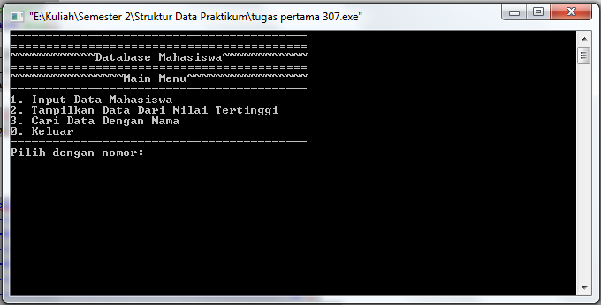

1. Menu Input

